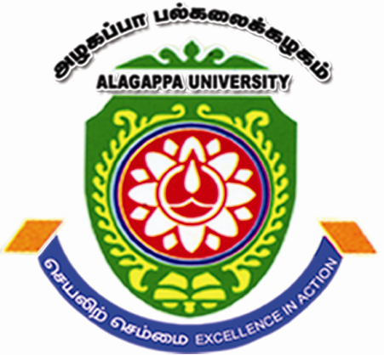 | ALAGAPPA UNIVERSITY  (A State University Reaccredited with “A” by NAAC)  Karaikudi – 630 003  ALAGAPPA INSTITUTE OF MANAGEMENT | 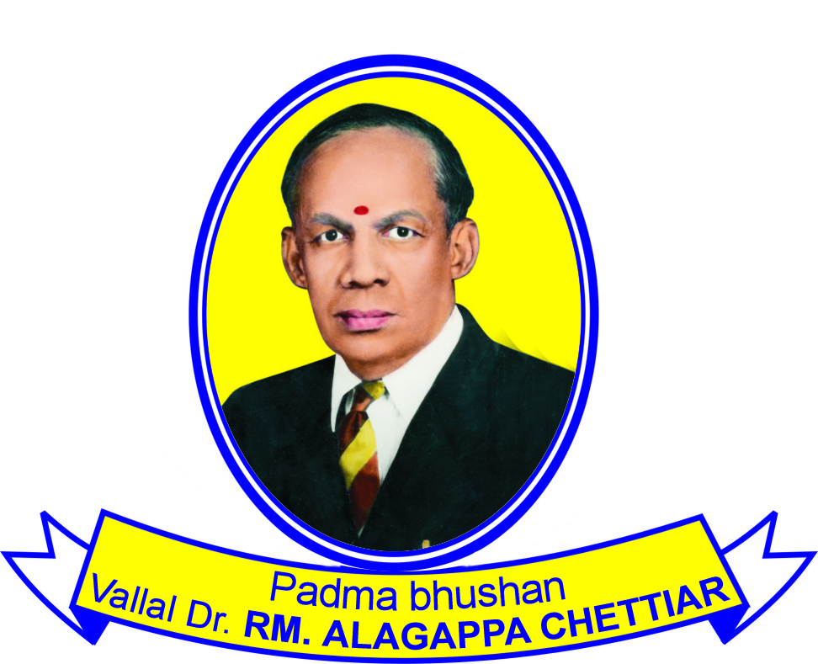

Dr. S. Kaliyamoorthy January 28, 2014.
Professor & Director – (Project Director-ICSSR)

Selection of Research Associate for ICSSR Major Research Project
Applications are invited from the eligible candidates for the post of Research Associate for a major Research Project entitled “A Study on the Aftermath of Liberalization in the Rural Villages of Tamilnadu” sponsored by the ICSSR. The interested candidates possessing the following qualifications are requested to appear for the Walk in Interview with Bio-data and essential attested copies of certificates to the below mentioned address at 11:00 AM on 28th February 2014.

Research Associate | Number of Position: One
Research Associate | Salary Per Month: Rs. 16000/-
Research Associate | Duration: 18 Months
Research Associate | Essential Qualification: Master Of Business Administration
Research Associate | Desirable Qualification: M.Phil in Management / NET / SET

NOTE
- No TA/DA will be paid for attending the interview.

Address for Communication

Dr. S. Kaliyamoorthy  Professor & Director  Project Director – (ICSSR)  Alagappa Institute of Management,  Alagappa University  Karaikudi – 630004  E-mail: drskaliyamoorthy@yahoo.co.in | Dr. P. S. Nagarajan  Assistant Professor  Project Co-Director-(ICSSR)  Alagappa Institute of Management  Alagappa University  Karaikudi - 630004  Mobile: 9444061581  E-mail: nagarajanalagappauniversity@gmail.com

